REPORT OF A RAPID NEEDS ASSESSMENT (RNA) CARRIED OUT AT ZAMZAM IDP CAMP AND NAIVASHA AREA AND THE HOST COMMUNITY IN EL FASHER LOCALITY OF NORTH DARFUR, ON 22ND JUNE 2023.
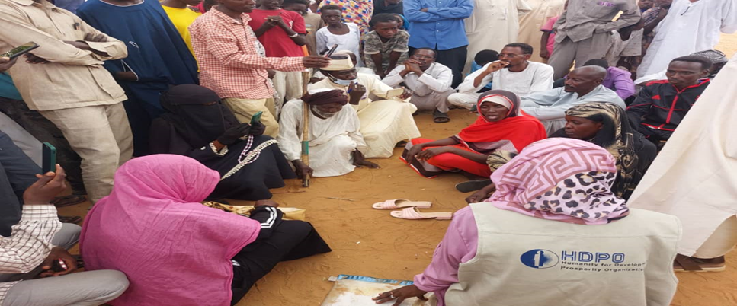
Tawila locality in North Darfur State has been subjected to sporadic attacks since June 16, 2023 forcing thousands of civilians to flee to different places with majority fleeing to the already existing Internally Displaced Persons (IDP) Camps in El Fasher, the capital of North Darfur state. These new attacks resulted in the death and injury of dozens of civilians and has worsened the already fragile humanitarian situation in El Fasher. Reports from locals indicates that majority of residents of Argo, Rwanda, Bargu, Dabah Nayrah and Dali IDP camps have fled their areas in fear of fighting escalations following attacks by armed militias on them. Majority of these have arrived at Naivasha & Zamzam IDP camps in El Fasher city while others took refuge in Jebel Marra in Central Darfur State.
On June 22nd 2023, Humanity for Development and Prosperity Org (HDPO) emergency response team on ground in North Darfur conducted a rapid needs assessment among the newly displaced people fleeing the armed attacks on Tawila locality (60 kms West of El Fasher City). The team visited the new arrivals who were camping at Zamzam IDP camp and Naivasha area, in schools and some hosted with relatives while others are stranded and currently living on streets.
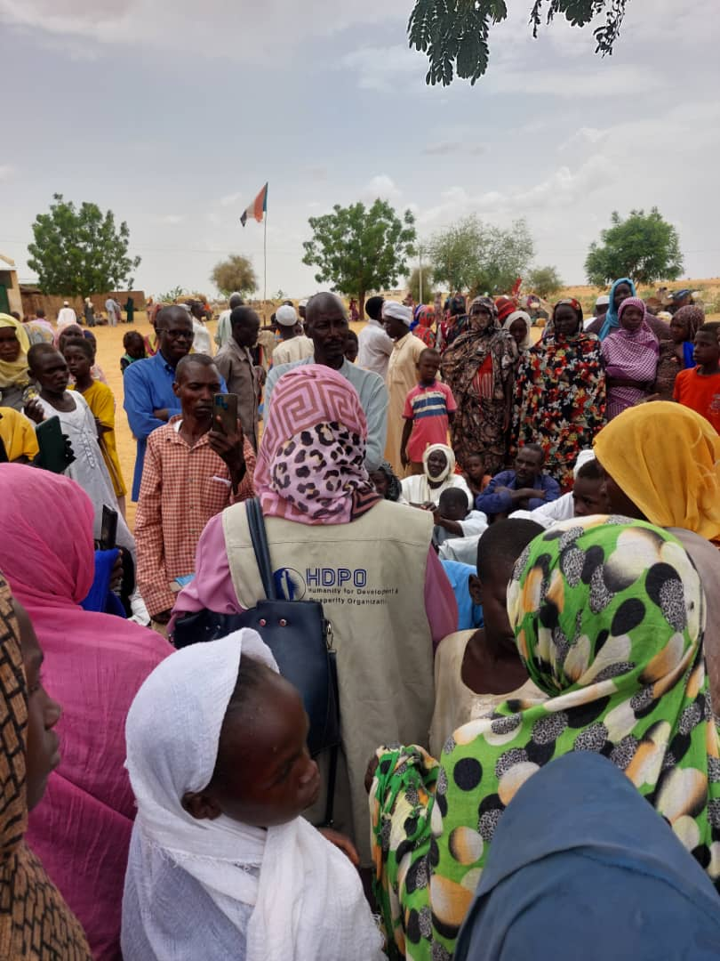
Objective of the Rapid Needs Assessment
The objective of the rapid needs assessment mission was to assess the overview of the situation of the newly arrived IPDs in terms of numbers and to identify the urgent humanitarian needs of the new arrivals at Zamzam and Naivasha IDPs camps in El Fasher.

Methodology:
The team conducted one-on-on interviews with the newly displaced persons arriving from Tawila and also had key informants interviews the IDPs leader. The team also held a Focus Group Discussion and physically observed the places where the new arrivals are residing.
Finding:
- The newly arrived IDPs reported that they are facing an acute shortage of essential needs especially, food, water, healthcare services, sleeping places and cooking utensils. Currently they are depending on assistance from host communities
- Most of the interviewed IDPs said do not have any money on them with which they could buy food stuff from the host community.
- There is an extreme shortage of water, hygiene and sanitation (WASH) facilities in the areas the newly displaced persons are living and the hosting families.
- The newly displaced persons narrated their personal interface with horrific violation of their rights by militants who killed their children, the elderly and women by firing directly at them, burning their homes, looting their property and reports of women being raped. A woman narrated that they tried to save their children using donkey carts but the soldiers blocked the roads, took away the donkeys and forced them to drag the carts by hand with children and elderly people on board.
Testimony of Kenina, a Survivor.
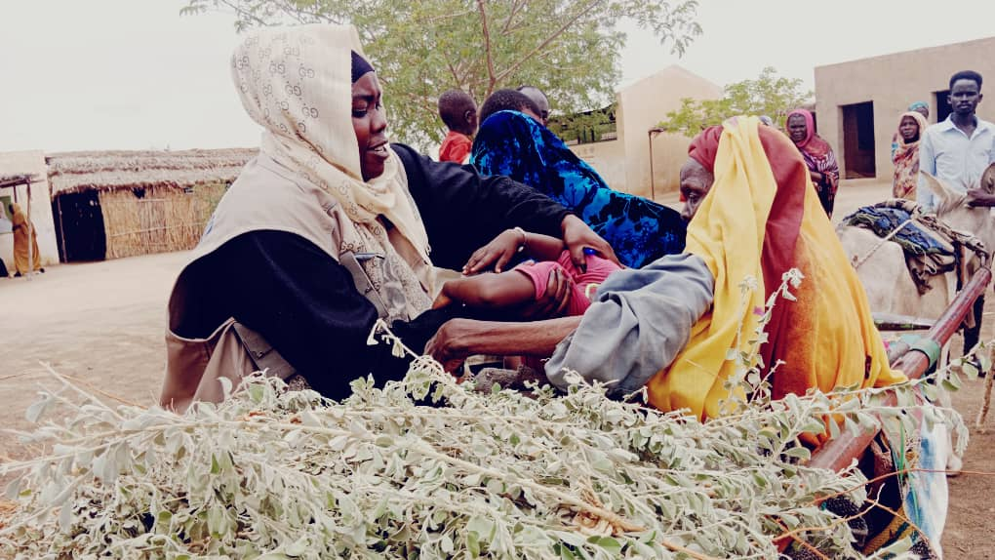
Kenina Ahmed Abakar, a survivor of the attack on the Rwanda camp in Tawila, says that gunmen using motorcycles, horses and camels and 4WD carrying all kinds of weapons wearing military and civilian uniforms attacked their camp at dawn on Friday, June 14,2023. The militants set their homes on fire and shot at them directly and heavily, forcing them to flee. She pointed out that she was able to take 6 of her 8 children, and arrived at Zamzam camp on foot, after spending 5 days on the way with others. Kenina in a sad tone said that she does not know the fate of two of her children with their father, who is a person with special needs. She said she, left them inside the house at the moment of the attack and without thinking she just ran with the six children she was able to take.
Total figures of the newly arrived IDPs from Tawila locality:
SN | Location | HHs | Individuals
1 | Zamzam IDP camp | 337 | 1112
2 | Naivasha area (schools etc..) | 195 | 720
 | TOTAL | 520 | 1832

URGENT INTERVENTIOND REQUIRED/ RECOMMENDATIONS
- There is urgent need to support the newly displaced population with shelter materials and Non-Food items to save lives and reduce their suffering.
- There is need for quick food distribution for the newly displaced and the vulnerable IDPs who have lived in those camps for years. Their state has been worsened by the new arrivals.
- There is need for provision of emergency sanitation facilities most urgently community latrines to prevent outbreak of diseases in the camps.
- There is need for Cash Based Interventions to empower the newly displaced persons to be able to get some basic needs based on their individual family needs.
- There is need for provision of medical services preferably using a mobile clinic methodology.
- Need for an interagency and sector cluster specific assessment to have an in-depth understanding of the individual cluster needs and intervention.
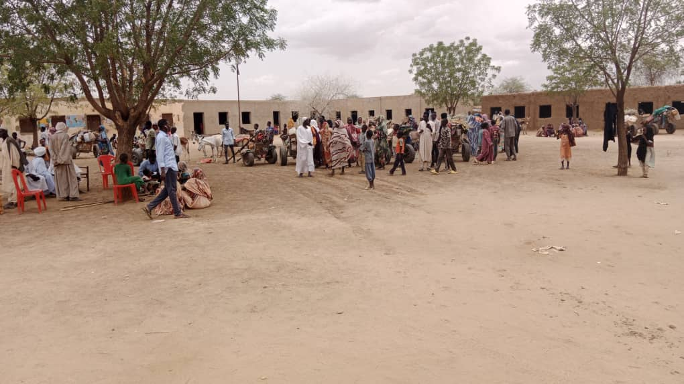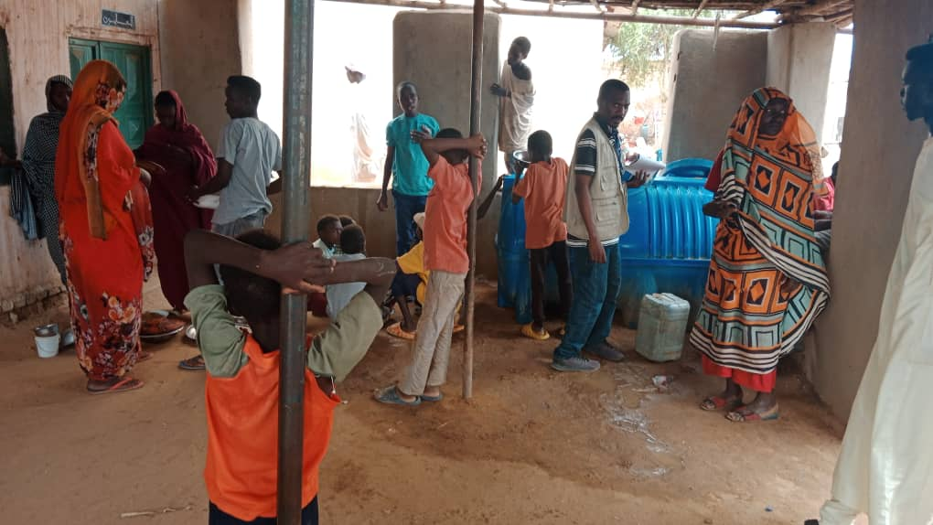

Report Prepared by:
HDPO Assessment Team in North Darfur.
23 Jun 23

